**Lab 10**

**A Digital Lock**

**Spring 2025**

Submitted by: **Mohsin Sajjad**

Registration No: **22pwsce2149**

Class Section: **A**

“On my honor, as student of University of Engineering and Technology, I have neither given nor received unauthorized assistance on this academic work.”

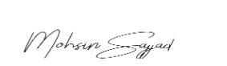

Student Signature: ______________

Submitted to:

**Engr. Faheem Jan**

Month Day, Year (18 05, 2025)

Department of Computer Systems Engineering

University of Engineering and Technology, Peshawar

**A Digital Lock**

**Objective:** Build an electronic combination lock with reset button, two number buttons (0 and 1), and an unlock output. The combination should be “01011”

**Block Diagram:** A combinational digital lock has three input buttons for Reset, entering a “0” and entering a “1” and output button UNLOCK and state which shows in which state the machine is currently in. The state output is connected to the seven segment display on the S6BOARD. The Module button in the below diagram is an abstraction of the synchronizer and level to pulse converter from the previous lab. The state transition diagram is given in the following figures.

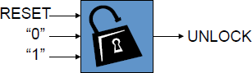

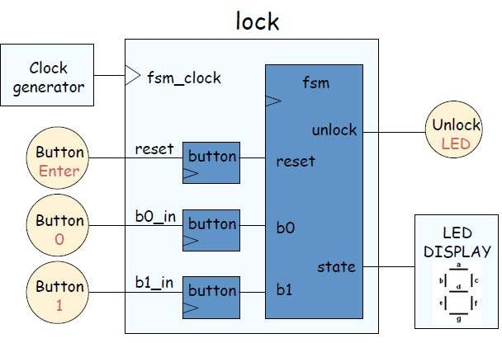

**State Transition Diagram:**

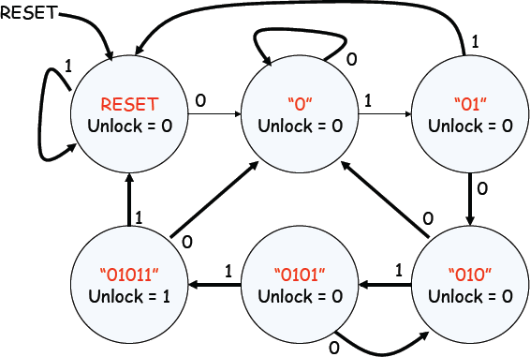

**Lab Tasks:**

1. Build an electronic combination lock with reset button, two number buttons (0 and 1), and an unlock output. The combination should be “01011”

**CODE:**module Lock(button0, button1, clk_in, rst, openLock, PS);

input button0, button1, clk_in, rst;

output openLock;

output reg [2:0]PS;

reg openLock;

parameter S0 = 3'b000,

S1 = 3'b001,

S2 = 3'b010,

S3 = 3'b011,

S4 = 3'b100,

S5 = 3'b101;

reg [2:0] state;

wire slowclock;

Clock_Divider cd(clk_in, slowclock);

always @(posedge slowclock) begin

if (rst) begin

openLock = 0;

state = S0;

end else begin

case (state)

S0: begin

if (!button0) // input 0

state = S1;

else if (!button1)

state = S0;

end

S1: begin

if (!button1) // input 1 => 01

state = S2;

else if (!button0)

state = S1;

end

S2: begin

if (!button0) // input 0 => 010

state = S3;

else if (!button1)

state = S0;

end

S3: begin

if (!button1) // input 1 => 0101

state = S4;

else if (!button0)

state = S1;

end

S4: begin

if (!button1) // input 1 => 01011

state = S5;

else if (!button0)

state = S1;

end

S5: begin

// Once unlocked, reset or wait for reset

if (!button0 || !button1)

state = S0;

end

endcase

end

PS <= state;

if (state == S5)

openLock = 1;

else

openLock = 0;

end

endmodule

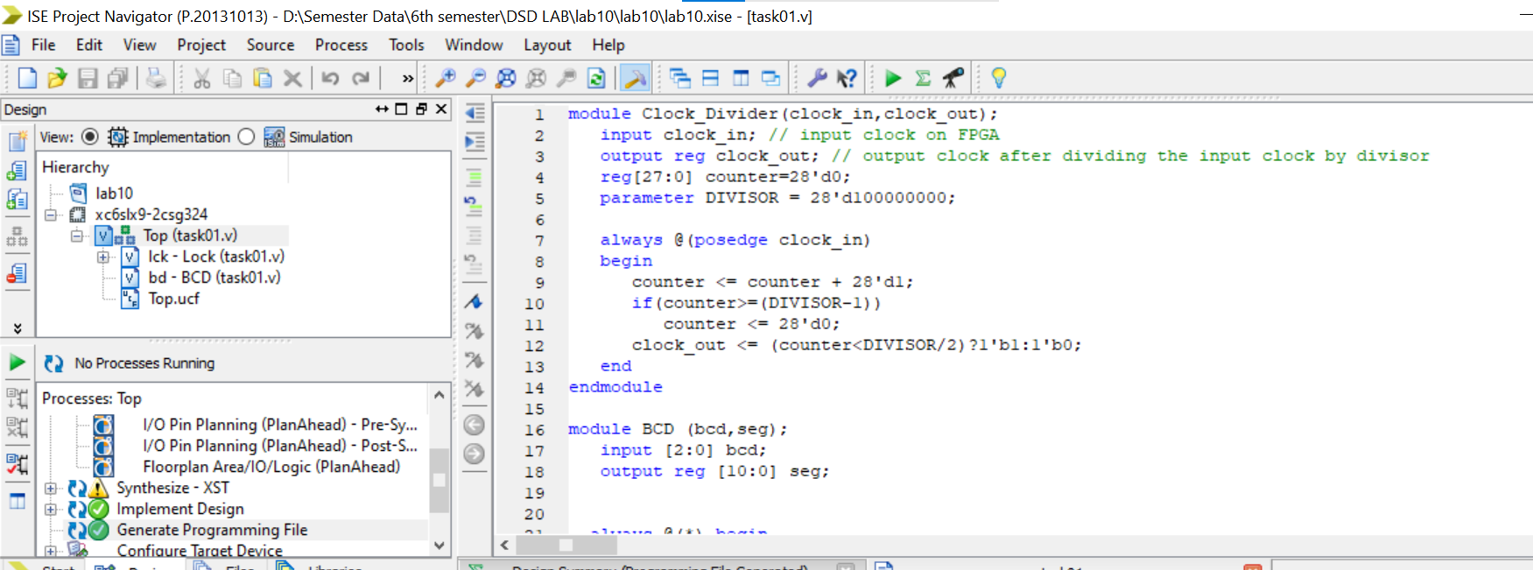

**output:**  
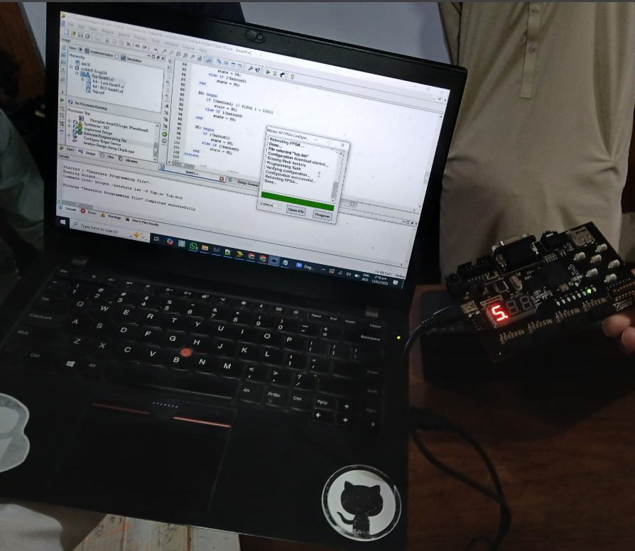

**Conclusion:**

This Verilog code implements a digital lock system that unlocks when the button sequence **01011** is entered. It uses a **finite state machine (FSM)** to track the input pattern, a **clock divider** to slow down the clock, and a **7-segment display module** to show the current FSM state. When the correct sequence is entered, the Unlock output goes high.

**TASk 02:**

**Change the functionality of the lock such that it unlocks on the sequence of 11011.**

**CODE:**module Clock_Divider(clock_in,clock_out);

input clock_in; // input clock on FPGA

output reg clock_out; // output clock after dividing the input clock by divisor

reg[27:0] counter=28'd0;

parameter DIVISOR = 28'd100000000;

always @(posedge clock_in)

begin

counter <= counter + 28'd1;

if(counter>=(DIVISOR-1))

counter <= 28'd0;

clock_out <= (counter<DIVISOR/2)?1'b1:1'b0;

end

endmodule

module BCD (bcd,seg);

input [2:0] bcd;

output reg [10:0] seg;

always @(*) begin

case(bcd)

3'b000: seg = 11'b10000000011; // 0

3'b001: seg = 11'b11110010011; // 1

3'b010: seg = 11'b01001000011; // 2

3'b011: seg = 11'b01100000011; // 3

3'b100: seg = 11'b00110010011; // 4

3'b101: seg = 11'b00100100011; // 5

default: seg = 11'b00000000011; // Error or Blank A

endcase

end

endmodule

module Lock(button0, button1, clk_in, rst, openLock, PS);

input button0, button1, clk_in, rst;

output openLock;

output reg [2:0]PS;

reg openLock;

parameter S0 = 3'b000,

S1 = 3'b001,

S2 = 3'b010,

S3 = 3'b011,

S4 = 3'b100,

S5 = 3'b101;

reg [2:0] state;

wire slowclock;

Clock_Divider (clk_in,slowclock);

always @(posedge slowclock) begin

if (rst) begin

openLock = 0;

state = S0;

end

else begin

case (state)

S0: begin

if (!button1) // first 1

state = S1;

else if (!button0)

state = S0;

end

S1: begin

if (!button1) // second 1 ? 11

state = S2;

else if (!button0)

state = S0;

end

S2: begin

if (!button0) // zero ? 110

state = S3;

else if (!button1)

state = S0;

end

S3: begin

if (!button1) // fourth 1 ? 1101

state = S4;

else if (!button0)

state = S0;

end

S4: begin

if (!button1) // fifth 1 ? 11011

state = S5;

else if (!button0)

state = S0;

end

S5: begin

if (!button1)

state = S0;

else if (!button0)

state = S0;

end

endcase

end //else

PS <= state;

if(PS==S5)

openLock = 1;

else

openLock = 0;

end // always end

endmodule

module Top(BT0, BT1, clk, rst, Unlock, seg);

input BT0, BT1, rst, clk;

output Unlock;

wire [2:0]PS;

output [10:0] seg;

Lock lck(BT0, BT1, clk, rst, Unlock, PS);

BCD bd(PS,seg);

endmodule 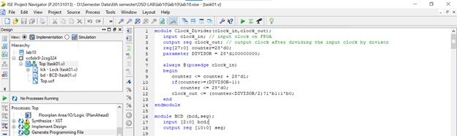

**Output:  
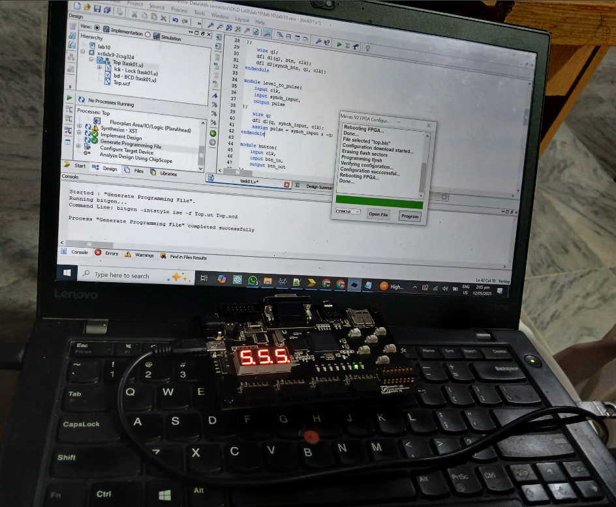**

**Conclusion:**

This Verilog code implements a digital lock system that unlocks when the button sequence **01011** is entered. It uses a **finite state machine (FSM)** to track the input pattern, a **clock divider** to slow down the clock, and a **7-segment display module** to show the current FSM state. When the correct sequence is entered, the Unlock output goes high.